WEEK 4 – ASSIGNMENT
Azure Cloud Fundamentals & Data Pipeline Implementation using ADF

Objective
Understand Azure cloud concepts and build an end-to-end data pipeline using Storage Account and Azure Data Factory.
Steps
Step 1 – Explore Azure Portal & Create Resource Group
- Log in to the Azure Portal and explore the interface
- Navigate to Resource Groups and create a new Resource Group

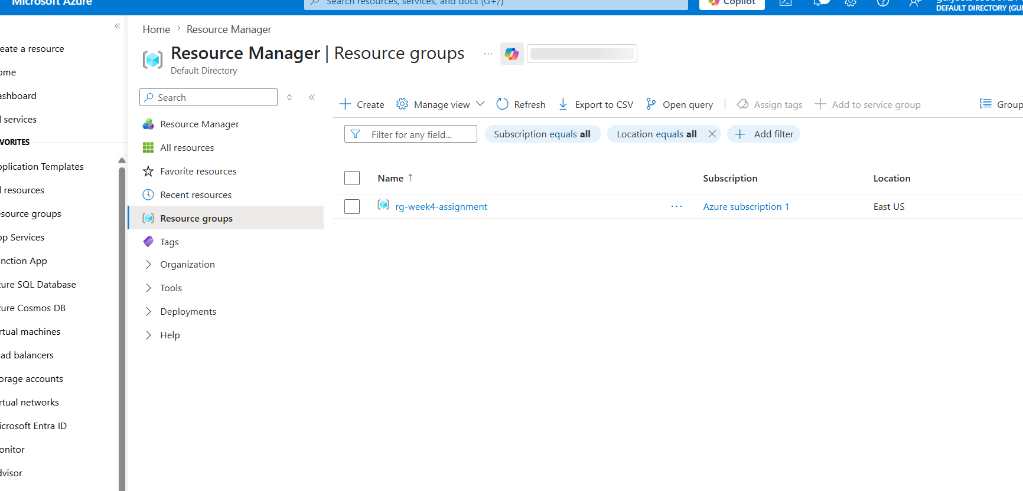
Screenshot – Azure Portal & Resource Group

Step 2 – Storage Account, Blob Container & CSV Upload
- Create a Storage Account within the Resource Group
- Create a Blob Container inside the Storage Account
- Upload a CSV file to the Blob Container

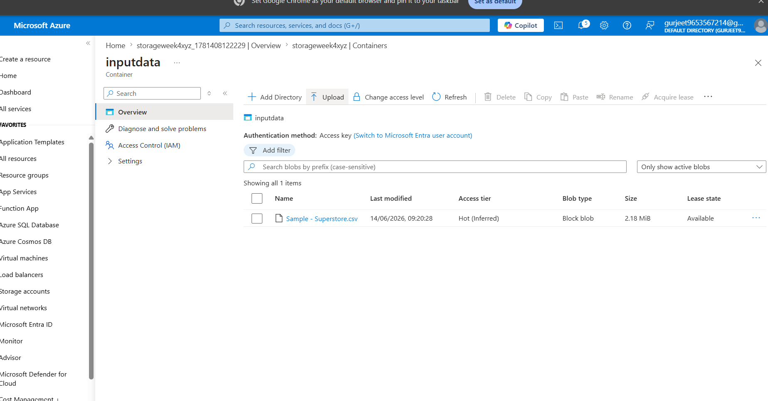
Screenshot – Storage Account with Uploaded CSV File

Step 3 – Create Azure Data Factory & Explore ADF UI
- Create an Azure Data Factory instance
- Explore the ADF UI: Author, Monitor, and Manage tabs

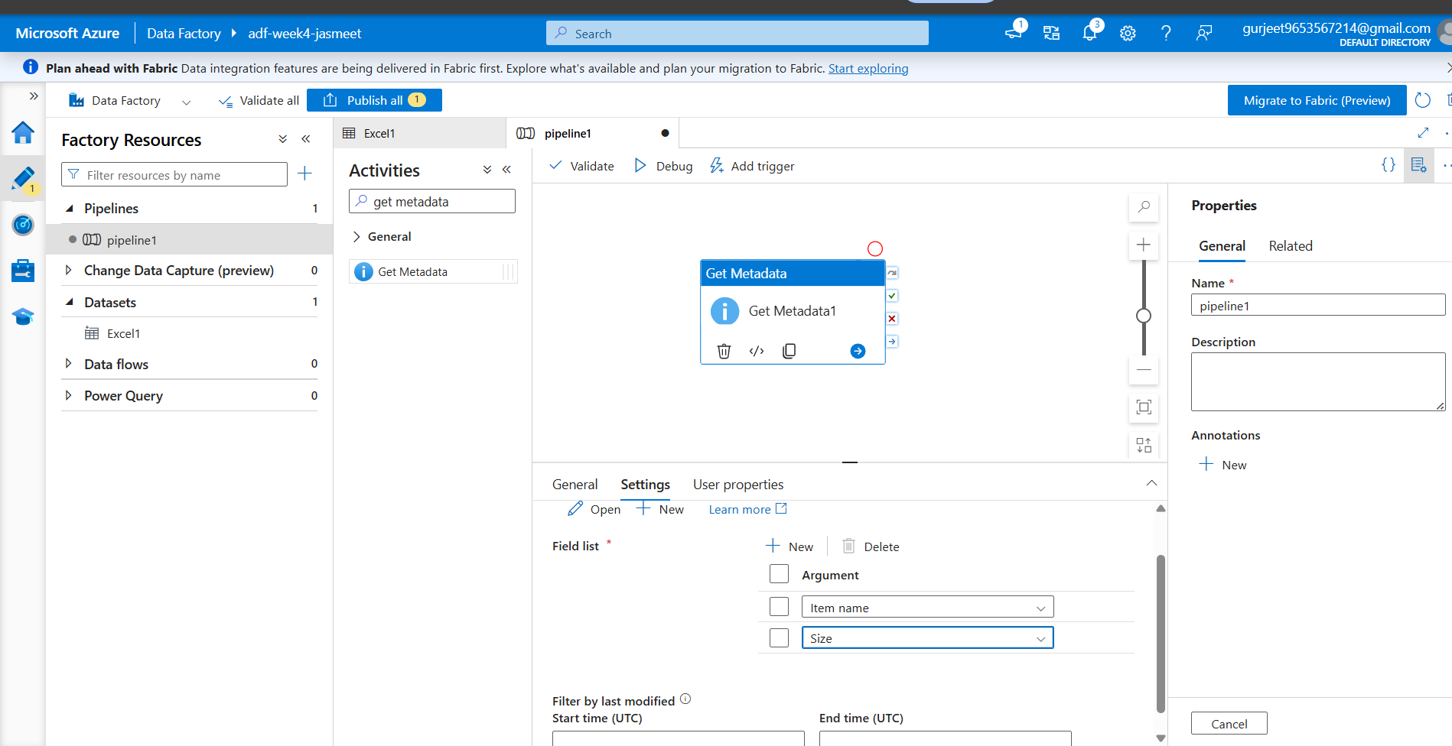
Screenshot – Azure Data Factory UI

Step 4 – Linked Service, Datasets & Get Metadata Activity
- Create a Linked Service connecting ADF to Blob Storage
- Create source and destination datasets
- Use the Get Metadata activity to retrieve file information

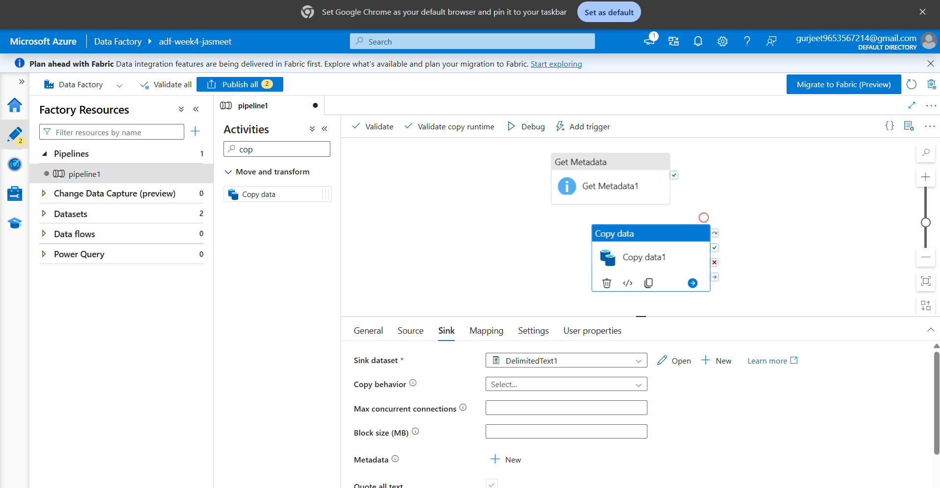
Screenshot – Linked Service, Datasets & Get Metadata

Step 5 – Build Pipeline with Copy Data Activity
- Create a new pipeline in ADF
- Add the Copy Data activity to the pipeline canvasConfigure source (Blob CSV) and destination settings

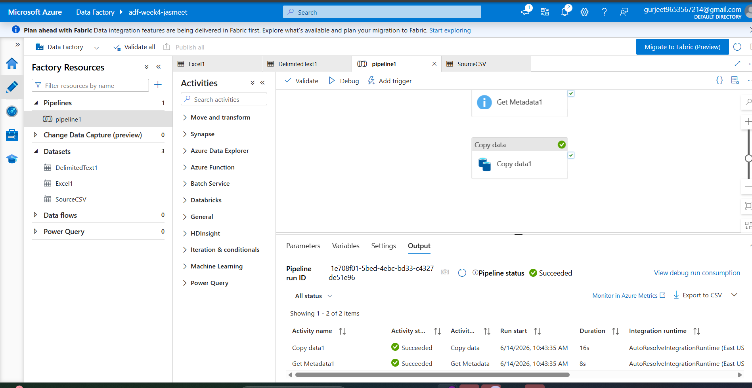
Screenshot – Pipeline with Copy Data Activity

Step 6 – Execute Pipeline & Monitor
- Trigger the pipeline using Debug or Add Trigger
- Monitor execution status in the Monitor tab
- Verify pipeline run shows Succeeded status

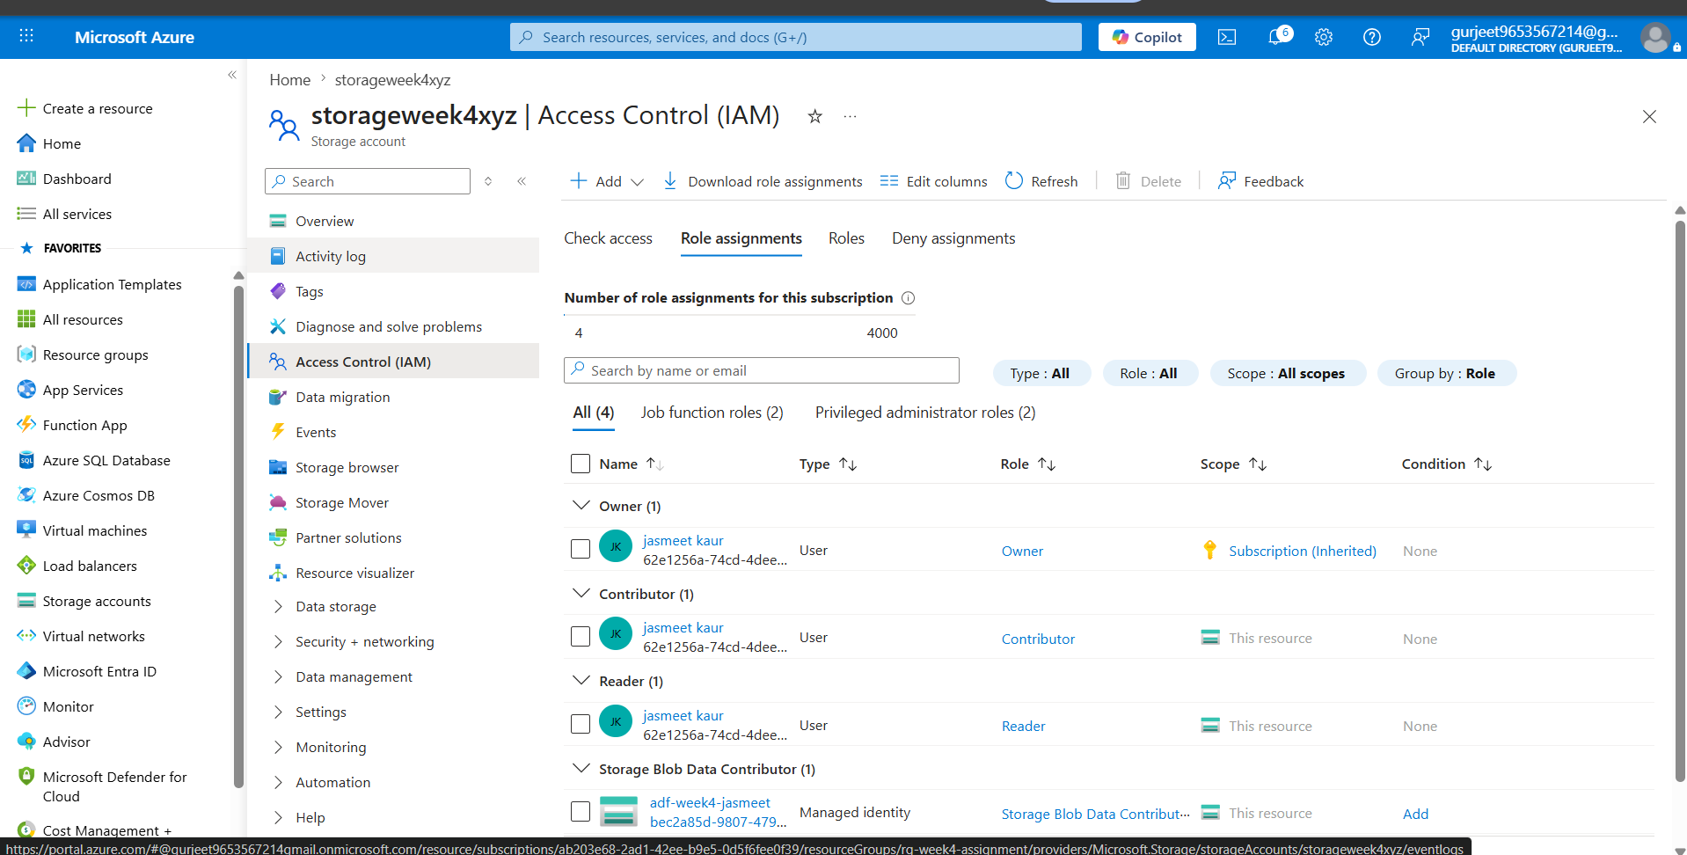
Screenshot – Pipeline Execution (Succeeded)

Step 7 – Assign IAM Roles & Configure Access
- Assign Reader and Contributor roles via IAM
- Grant ADF the required access to the Storage Account

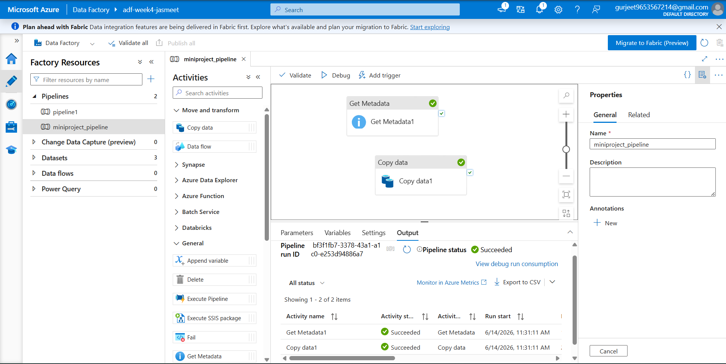
Screenshot – IAM Role Assignment

Output
End-to-End Pipeline: Blob Storage → ADF → Destination
- Resource Group created successfully
- Storage Account and Blob Container configured with CSV file
- ADF instance created with Linked Service and Datasets
- Pipeline built using Copy Data and Get Metadata activities
- Pipeline executed and completed with Succeeded status
- Data copied to the destination location
- Metadata validated via Get Metadata activity
- IAM roles (Reader, Contributor) assigned and access configured

Summary
This week's assignment provided hands-on experience with Microsoft Azure's core cloud services. Starting from the Azure Portal, a Resource Group was created to logically organize all resources. A Storage Account and Blob Container were set up to host the source CSV file. Azure Data Factory was then configured with a Linked Service and datasets to establish connectivity between the storage and pipeline. A pipeline was built using the Copy Data activity to move data from Blob Storage to a destination, with the Get Metadata activity validating file metadata before processing. The pipeline was successfully executed and monitored, confirming end-to-end data flow. Finally, IAM roles were assigned to enforce proper access control between ADF and the Storage Account, completing a fully functional and secure data pipeline.

